# Compass – Prescription Savings Guide

Sample Prescription Savings Guide

Handling Calls about Prescription Savings Guides

Related Documents

**Description:** Information about the Prescription Savings Guide which is a letter mailed to members that provides information about opportunities to support therapy adherence and cost reduction.

|  |
| --- |
| Sample Prescription Savings Guide |

**Note:** Prescription Savings Guides are not sent to Medicare D beneficiaries

This is a client-specific option. Members receive letters only if their plan has opted in. The client determines which member populations receive the guide. They may choose to send the guide only to members who have a savings of $50 or more or elect to send to their entire membership regardless of savings. Most clients select to send the guides out annually; however, some send them twice a year or quarterly. Refer to the CIF for client-specific information about the guide.

Each guide is customized for the member and the client’s plan design. They are printed in English and are not available in Spanish or any other language.

The outer pages of the Prescription Savings Guide provide the following information:

* Introduction to the guide and the type of information the member is inside.
* Frequently Asked Questions about PBMs, generics, preferred brands, 90-day supplies, and available tools and resources such as the member web portal.
* An explanation for why Pharmacy Benefit Manager (PBM) has sent the Prescription Savings Guide, and how it is personalized for the member.

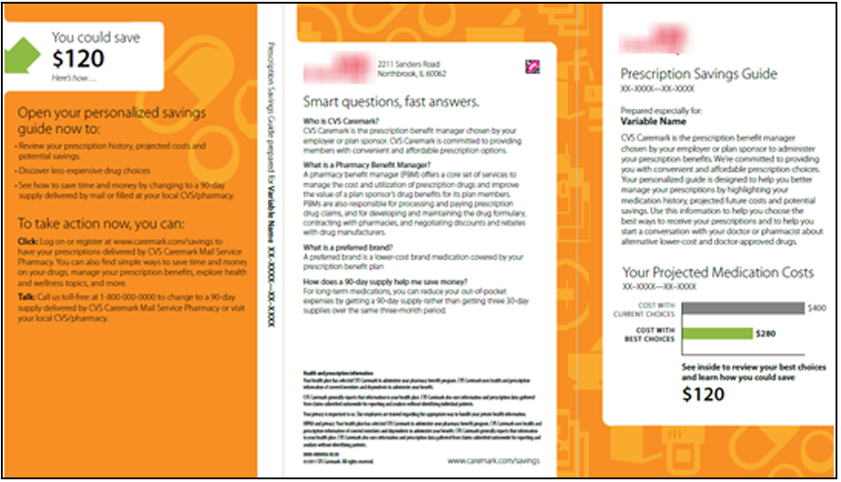

The inner pages of the guide provide the following information:

* A table of the member’s prescription history, comparing the drug cost paid with the member’s current choice and the potential savings if the best choice is used.
* Icons to indicate where the member could benefit by using a generic/preferred drug and/or 90-day supply. It also recognizes with a checkmark when the member has already made the best choice. Plan notes are included where appropriate.
* Steps the member can take to save which are based on the results shown in the table. Additional information about the member’s plan is included, such as Maintenance Choice, Mail Service, 3-Tier Copay, Coinsurance, etcetera.

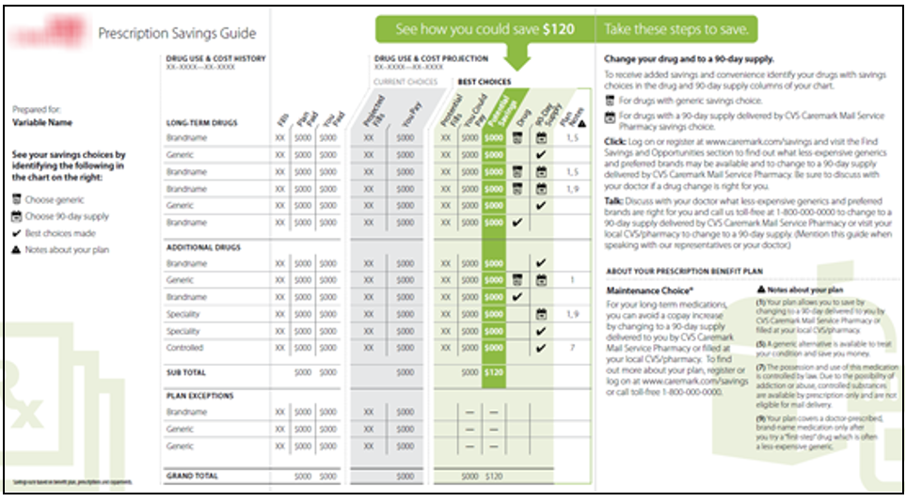

Top of the Document

|  |
| --- |
| Handling Calls about Prescription Savings Guides |

**Note:** View the template in the **Communication History** screen. It is not specific to the member however it identifies that the member was sent a Prescription Savings Guide.

Use as needed:

|  |  |
| --- | --- |
| **Scenario** | **Suggested Actions** |
| Member calls and states they have received a Prescription Savings Guide. | 1. Ask the member which features they would like to discuss further.   Topics that may be included in the letter are:   * Generic equivalents or formulary alternatives for brand medications * 90-day prescriptions and related plan designs, such as mail Service, Maintenance Choice, Retail 90 and our retail 90. * Mandatory Mail and Incentivized Mail plan designs * Prior Authorization, Step Therapy and Refill Limitation alerts  1. Follow existing procedures for consulting with the member on these benefit features and/or restrictions. |
| Member calls in about switching to a preferred drug. The Prescription Savings Guide tells her that they will save money and does not include the name of the drug. She is not sure what to do. How would you assist Ms. Smith? | 1. Run a [Test Claim (050041)](https://thesource.cvshealth.com/nuxeo/thesource/#!/view?docid=60c20ea0-1d07-46e3-809a-b54734b80fbe) for the drug in question.  2. Click on the **View hyperlink** in the **Alternatives** column to check for alternatives.  3. Select one or two and run test claims for them to compare the pricing.  **Reminders:**   * Consult other resources such as preferred/formulary drug lists. * Advise member to follow up with their prescriber to obtain a new prescription and to make sure an alternative is right for them. |
| Member calls in about switching to a 90-day supply. They only received 30-day supplies in the past from their local pharmacy, and the Prescription Savings Guide says they can save a lot of money by using 90-day supplies instead. What would you do? | 1. Review the member’s plan first to see which 90-day supply options are available, such as Maintenance Choice, Retail 90, etcetera.  2. Run a [Test Claim (050041)](https://thesource.cvshealth.com/nuxeo/thesource/#!/view?docid=60c20ea0-1d07-46e3-809a-b54734b80fbe) for medications in question to confirm savings, then consult with the member on which available options he prefers.   * Mail service, offer to initiate a new Rx request. Refer to [Compass - Obtaining a New Prescription (Rx) for the Member (New Rx Request) (054208)](https://thesource.cvshealth.com/nuxeo/thesource/#!/view?docid=a7684ce9-c2bc-4cbc-ab37-c1ffb7789706). * Have prescriber call or fax in a new prescription. * Retail, advise the member to contact their prescriber and request a prescription for a 90-day supply to be sent to the member’s selection of our retail stores. |
| Member calls in about their Prescription Savings Guide. It says current use is the best choice in choosing a generic for their migraine medication. However, there is a plan note that says:  “Your plan covers this medication in limited amounts. Your doctor decides the amount that is right for you. If you get a larger amount of medication, you are responsible for the additional cost.”  They are concerned about this - they never had any problems filling their prescription before and wants to know more about this. | 1. Run a [Test Claim (050041)](https://thesource.cvshealth.com/nuxeo/thesource/#!/view?docid=60c20ea0-1d07-46e3-809a-b54734b80fbe) for the medication in question.  2. Use the quantity the member is receiving first and check the results for quantity information.   * If none are shown, try another test claim “overshooting” the limit.   **Example:** Quantity of 90 if member currently receives quantity of 18.  3. Review the results and advise the member accordingly. As long as member stays within the plan limit, there is no need for concern. |

Top of the Document

|  |
| --- |
| Related Documents |

[Log Activity/Capture Activity Codes (005164)](https://thesource.cvshealth.com/nuxeo/thesource/#!/view?docid=bdac0c67-5fee-47ba-a3aa-aab84900cf78)

[Customer Care Abbreviations, Definitions, and Terms Index (017428)](https://thesource.cvshealth.com/nuxeo/thesource/#!/view?docid=c1f1028b-e42c-4b4f-a4cf-cc0b42c91606)

Top of the Document

Not to Be Reproduced or Disclosed to Others without Prior Written Approval

**ELECTRONIC DATA = OFFICIAL VERSION / PAPER COPY = INFORMATIONAL ONLY**